**Name:**

**Resource Rich Section**

TIME ALLOWED: 15 min Total marks: 17

**Question 10  [2 marks]**

Solve:

 for 

Question 11 [4 marks]

Describe how to transform the graph of  to obtain the graph of 

**Question 12 [2 marks]**

If *P*(*x*) = 2*x*4 + 4*x*3+ 2*x*2 – 5*x* – 8*,* find *P*(4)

Question 13 [9 marks]

A small object is moving in a straight line towards and away from a fixed point.

The horizontal distance, *d* m, of the object from at time *t* seconds is given by the function.

.

(a) Determine the distance of the object from  when . (1 mark)

(b) Draw the graph of  on the axes below for . (3 marks)

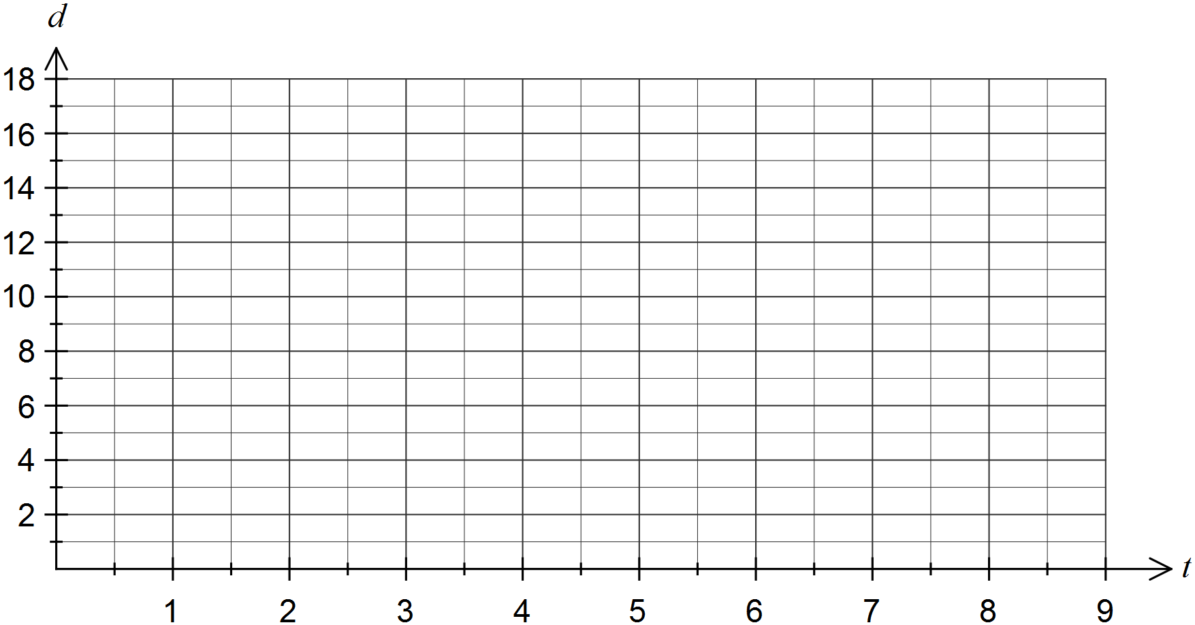

(c) State the amplitude and period of the graph of . (2 marks)

(d) Determine the time, to the nearest tenth of a second, when the object was first at a distance of 16 metres from . (1 mark)

(e) Determine the distance travelled by the object between  and . (2 marks)

END OF TEST